TA Recruitment System User Manual

Date: May 24, 2026

Table of Contents

1. [Introduction](1-introduction)
2. [Getting Started](2-getting-started)
3. [TA User Guide](3-ta-user-guide)
4. [MO User Guide](4-mo-user-guide)
5. [Admin User Guide](5-admin-user-guide)
6. [FAQ](6-faq)
7. [Contact Support](7-contact-support)

1. Introduction

Welcome to the TA Recruitment System! This system helps manage the Teaching Assistant recruitment process at BUPT International School.

Who Should Use This Guide?
- TA Applicants: Students looking for TA positions
- Module Organizers (MO): Faculty members posting TA jobs
- Administrators: System administrators managing users and settings

System Features
- Create and manage profiles
- Browse and apply for TA positions
- Post job openings
- Track application status
- Manage workload and users

2. Getting Started

2.1 Login

1. Open your web browser and go to the system URL
2. You will see the login page:

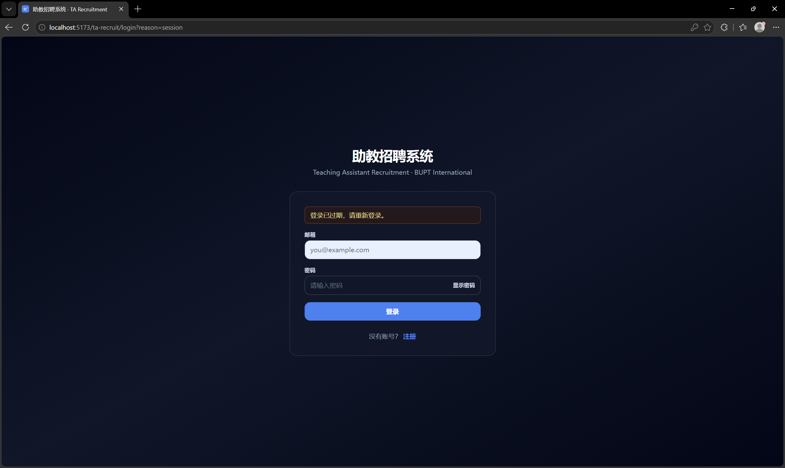

3. Enter your Email and Password
4. Click Login button

2.2 Register (First Time Users)

1. Click Register link on the login page
2. Fill in the registration form:
- Email address
- Password
- Display name
- Student ID (if applicable)
- Select role: TA or MO
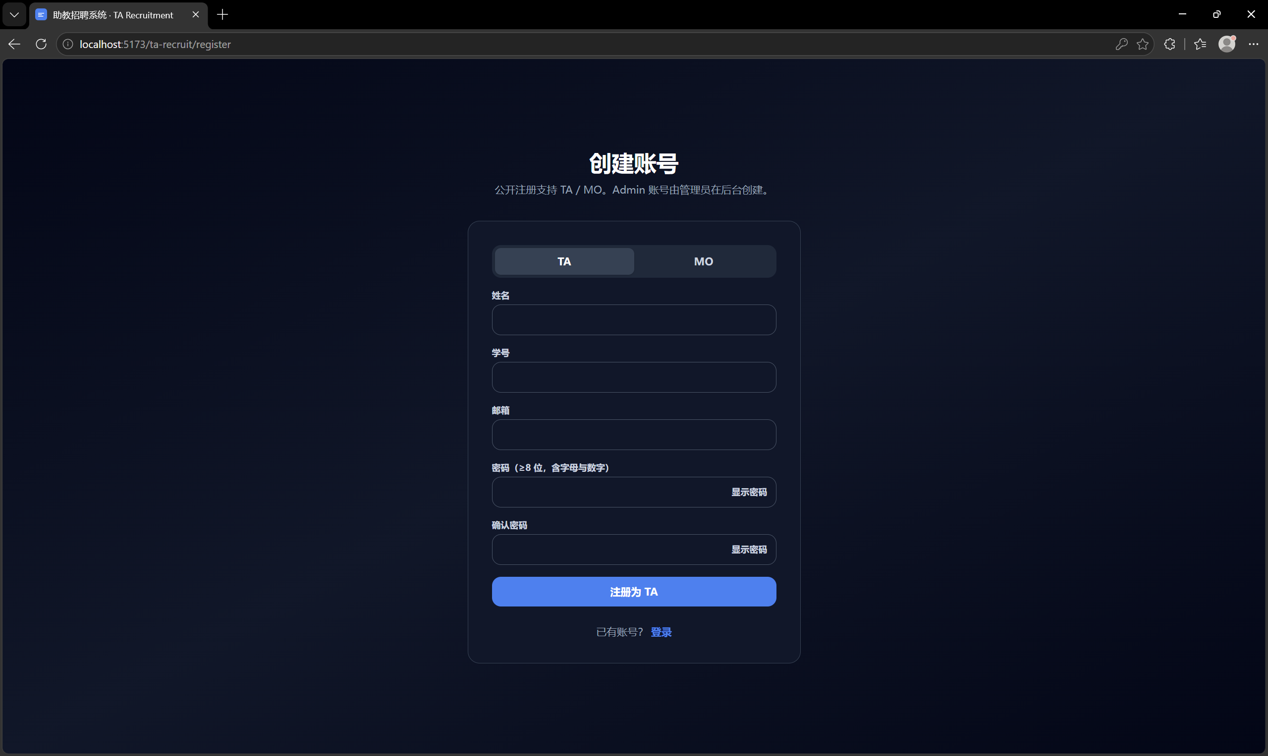

3. Click Register button

2.3 Dashboard Overview

After login, you will see your dashboard based on your role:
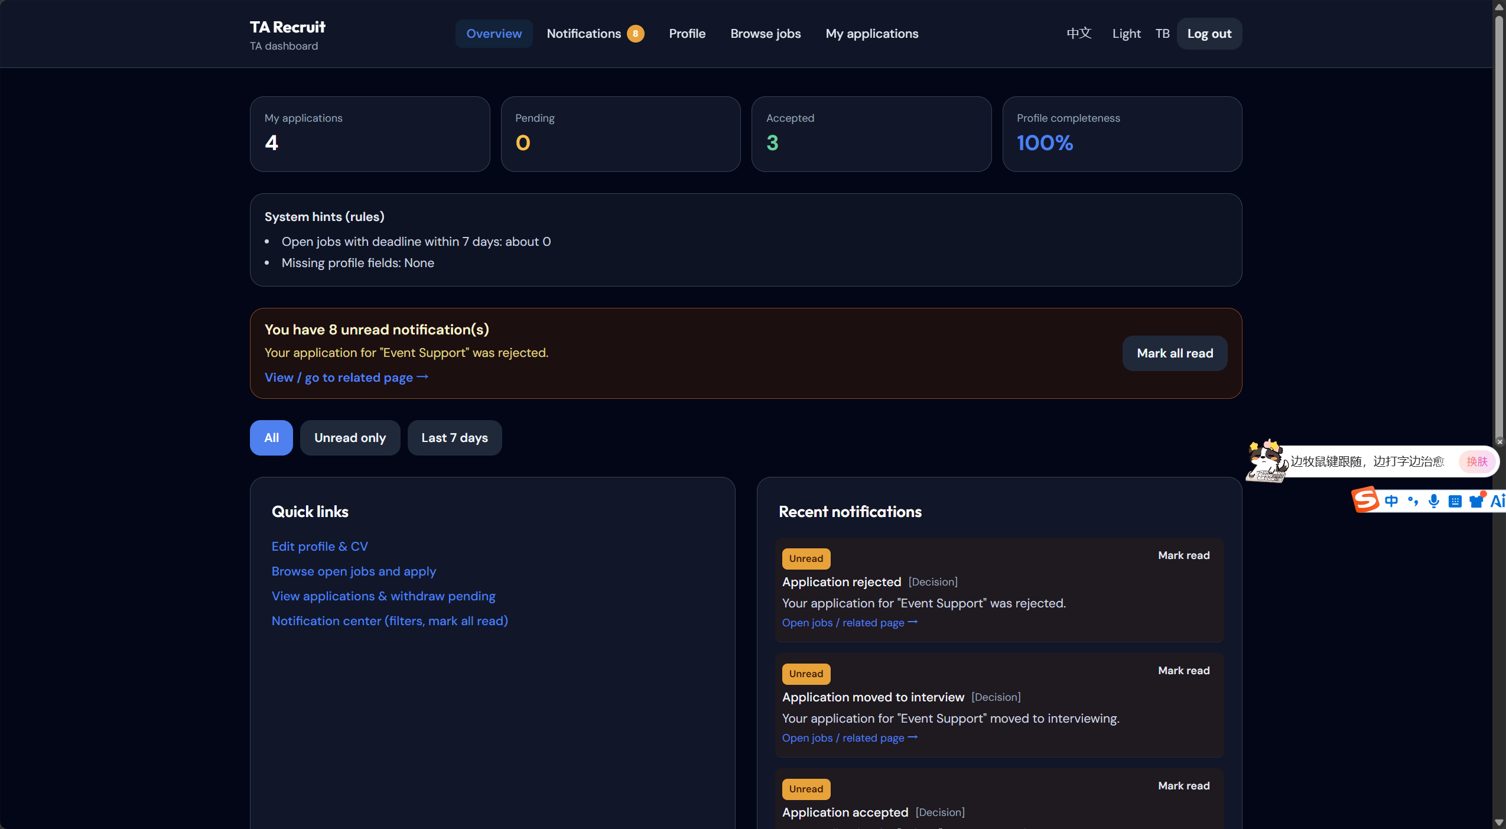

3. TA User Guide

As a TA applicant, you can:
- Create and update your profile
- Upload your CV
- Browse available jobs
- Apply for positions
- Track application status

3.1 Update Your Profile

1. Click Profile in the navigation menu
2. Fill in your information:
- Display name
- Student ID
- Skills (comma separated)
- Preferred courses
- Languages
- Availability
- Maximum weekly hours
- TA history
- Certificates
- GPA

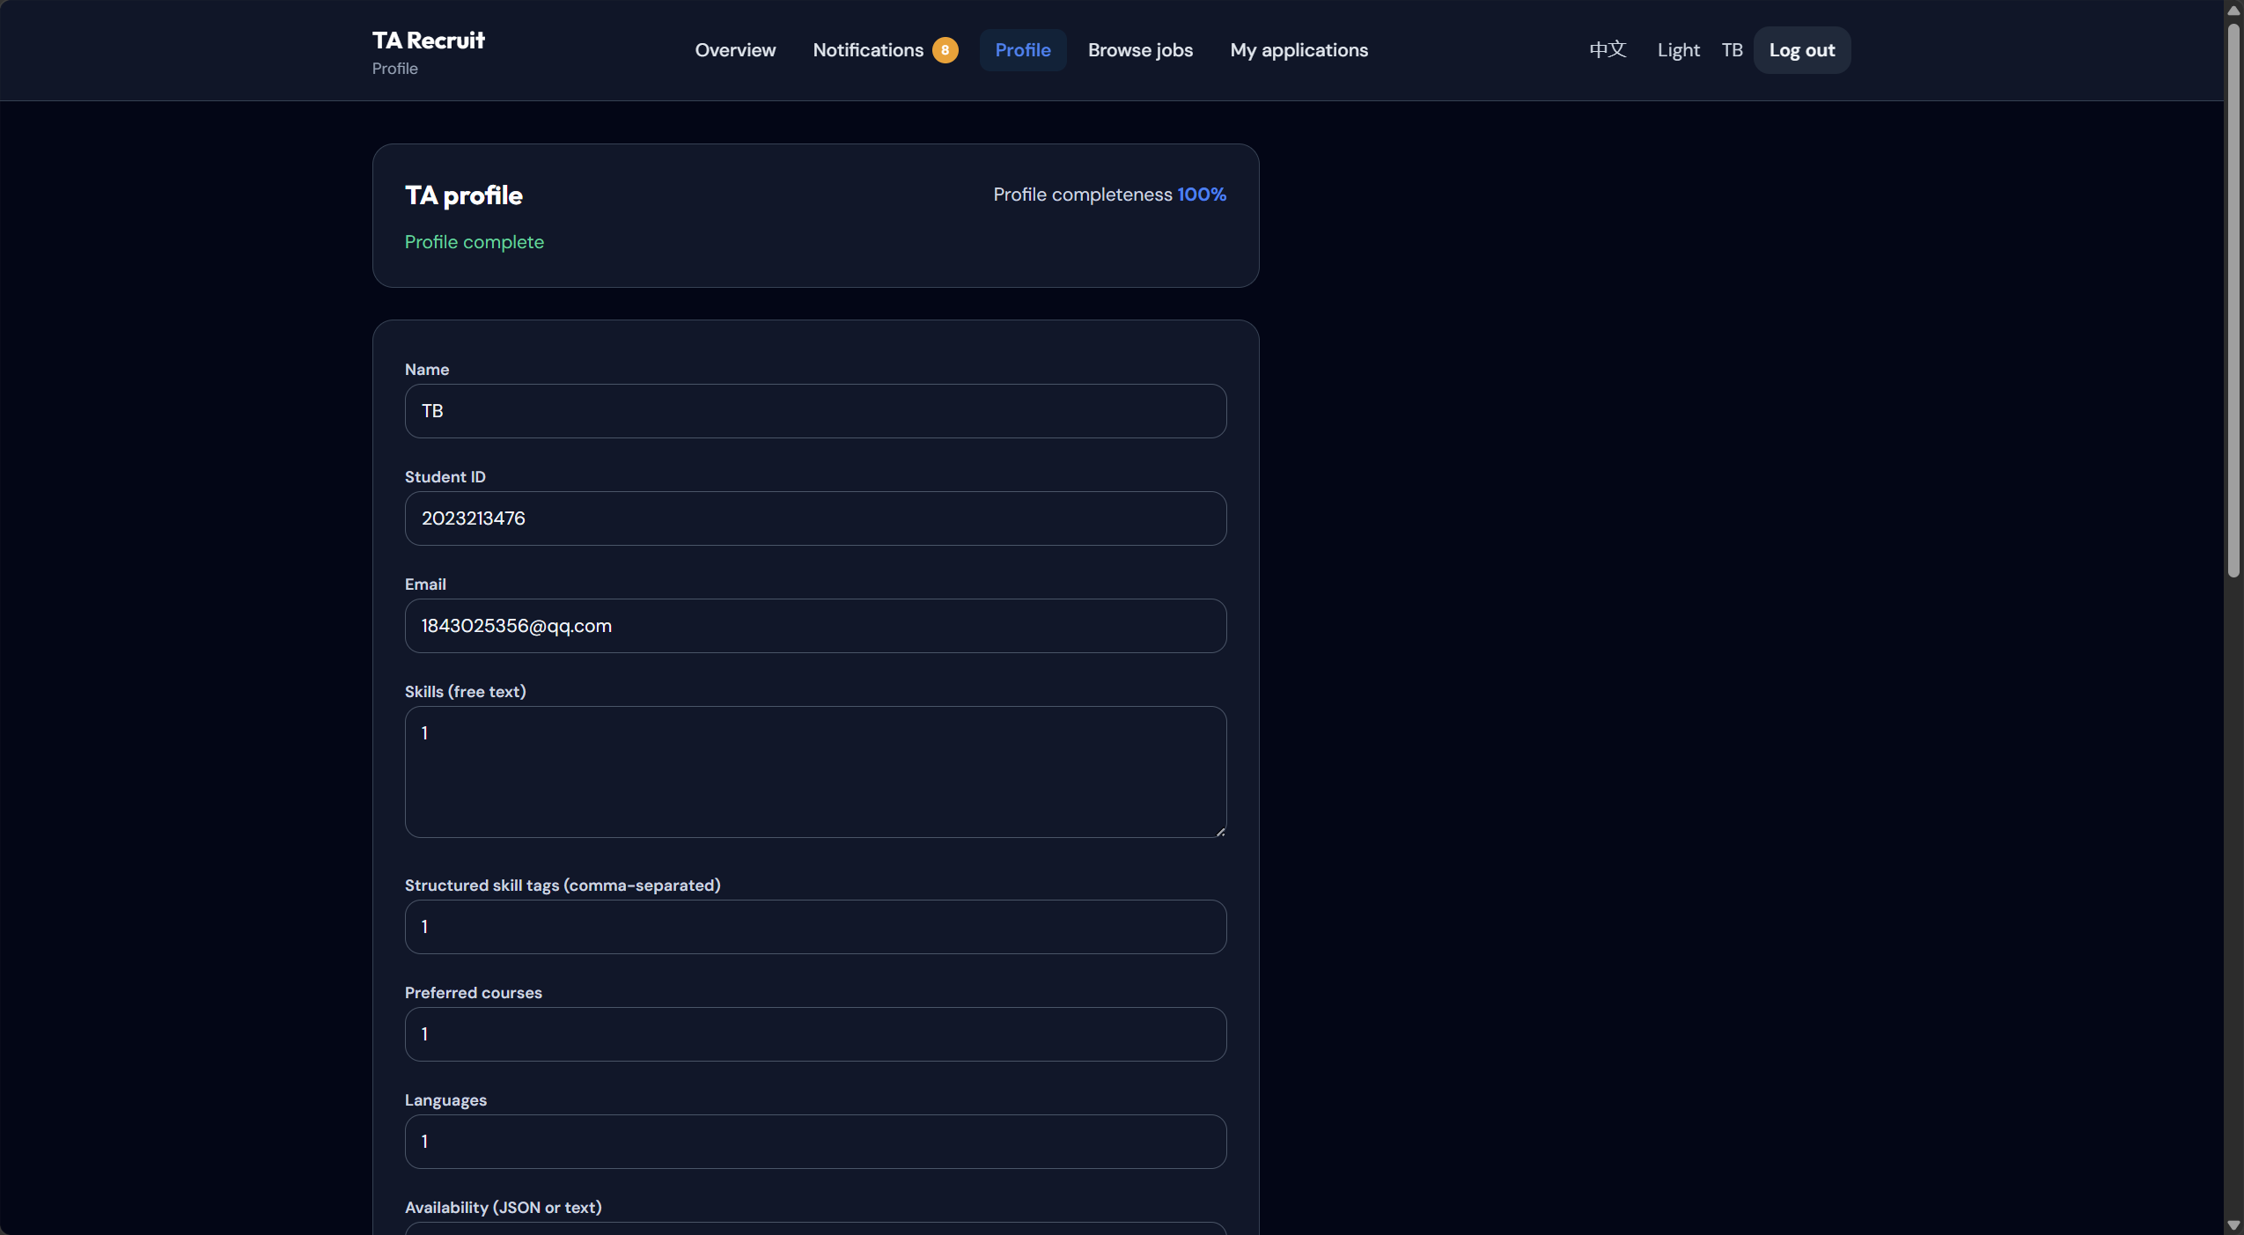

3. Click Save to update

3.2 Upload CV

1. Go to Profile page
2. Click Upload CV button
3. Select a PDF or Word file from your computer
4. Click Submit to upload

3.3 Browse Jobs

1. Click Jobs in the navigation menu
2. You will see a list of available jobs:

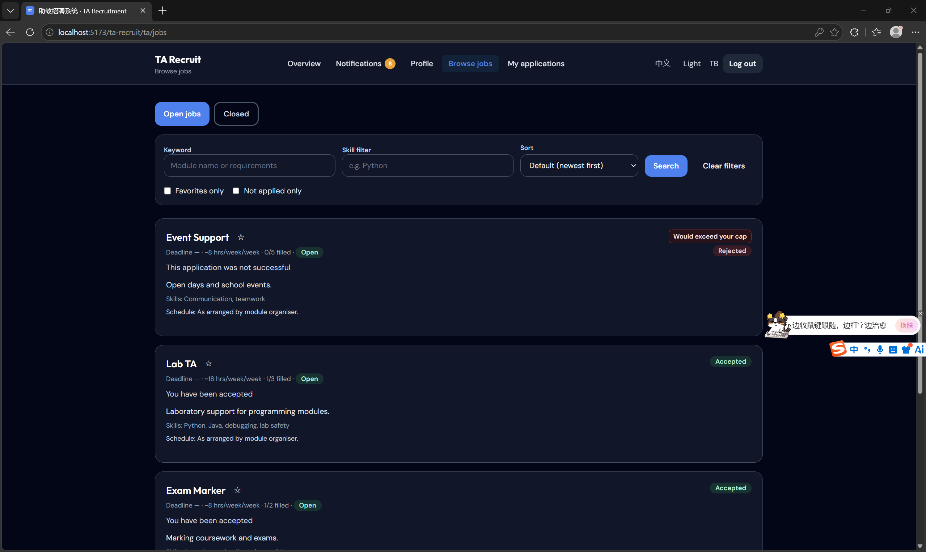
3. Use filters to find jobs:
- Search by keyword
- Filter by skill
- Filter by status

3.4 Apply for a Job

1. Click on a job title to view details
2. Review the job requirements and deadline
3. Click Apply button if interested
4. Confirm your application

3.5 Track Applications

1. Click My Applications in the navigation menu
2. You will see all your applications with status:
- Pending: Waiting for review
- Interviewing: Selected for interview
- Accepted: Job offer received
- Rejected: Application declined
- Withdrawn: You withdrew the application
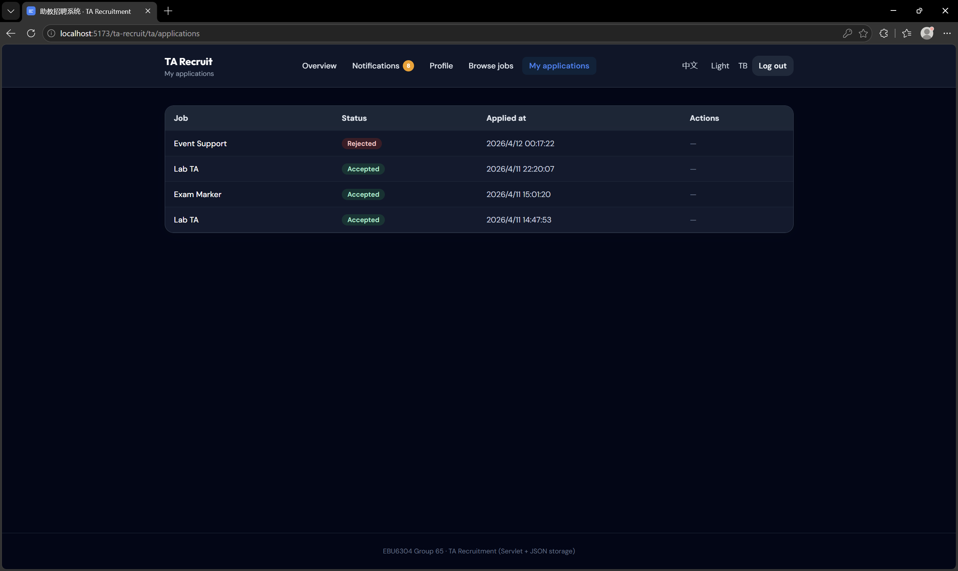

3.6 Save Favorite Jobs

1. On the jobs list page, click the star icon next to any job
2. The star will turn yellow, indicating it's saved
3. Click Favorites Only filter to see your saved jobs

4. MO User Guide

As a Module Organizer, you can:
- Post new TA jobs
- Manage job postings
- Review applicants
- Evaluate candidates
- Make hiring decisions

4.1 Post a New Job

1. Click Post Job in the navigation menu
2. Fill in the job form:
- Module name
- Job type
- Term/semester
- Requirements
- Skill tags
- Deadline
- Assigned hours
- Quota (number of positions)

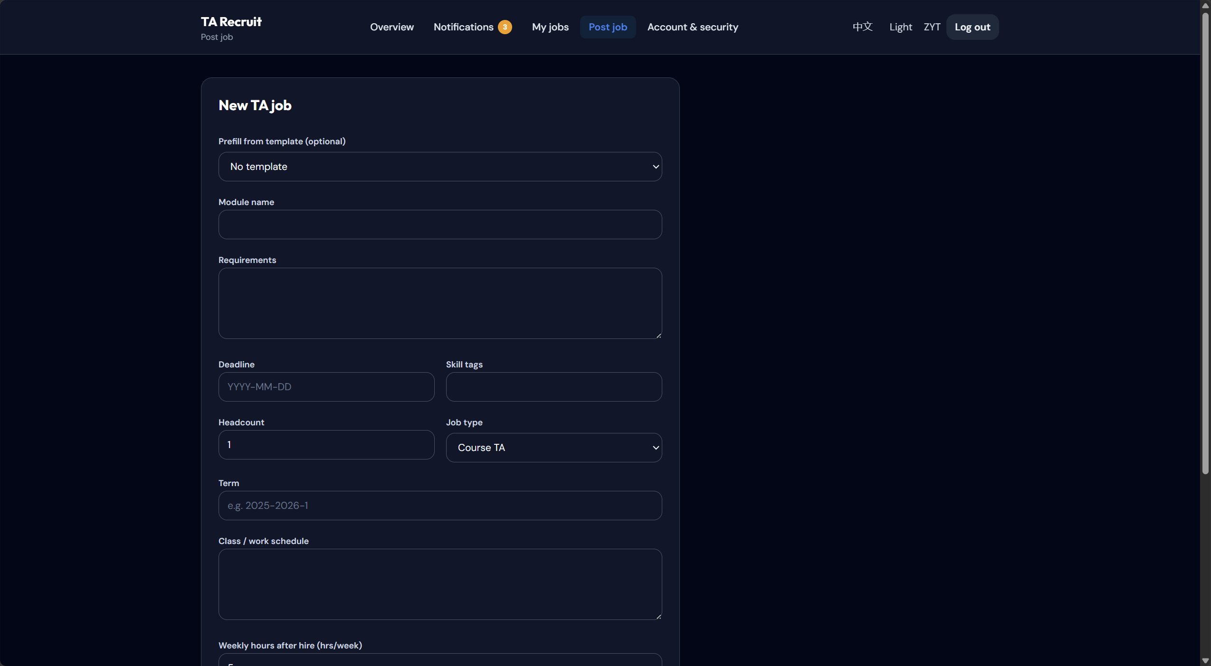

3. Click Save as Draft or Publish

4.2 Manage Jobs

1. Click My Jobs in the navigation menu
2. You will see all your posted jobs with status:

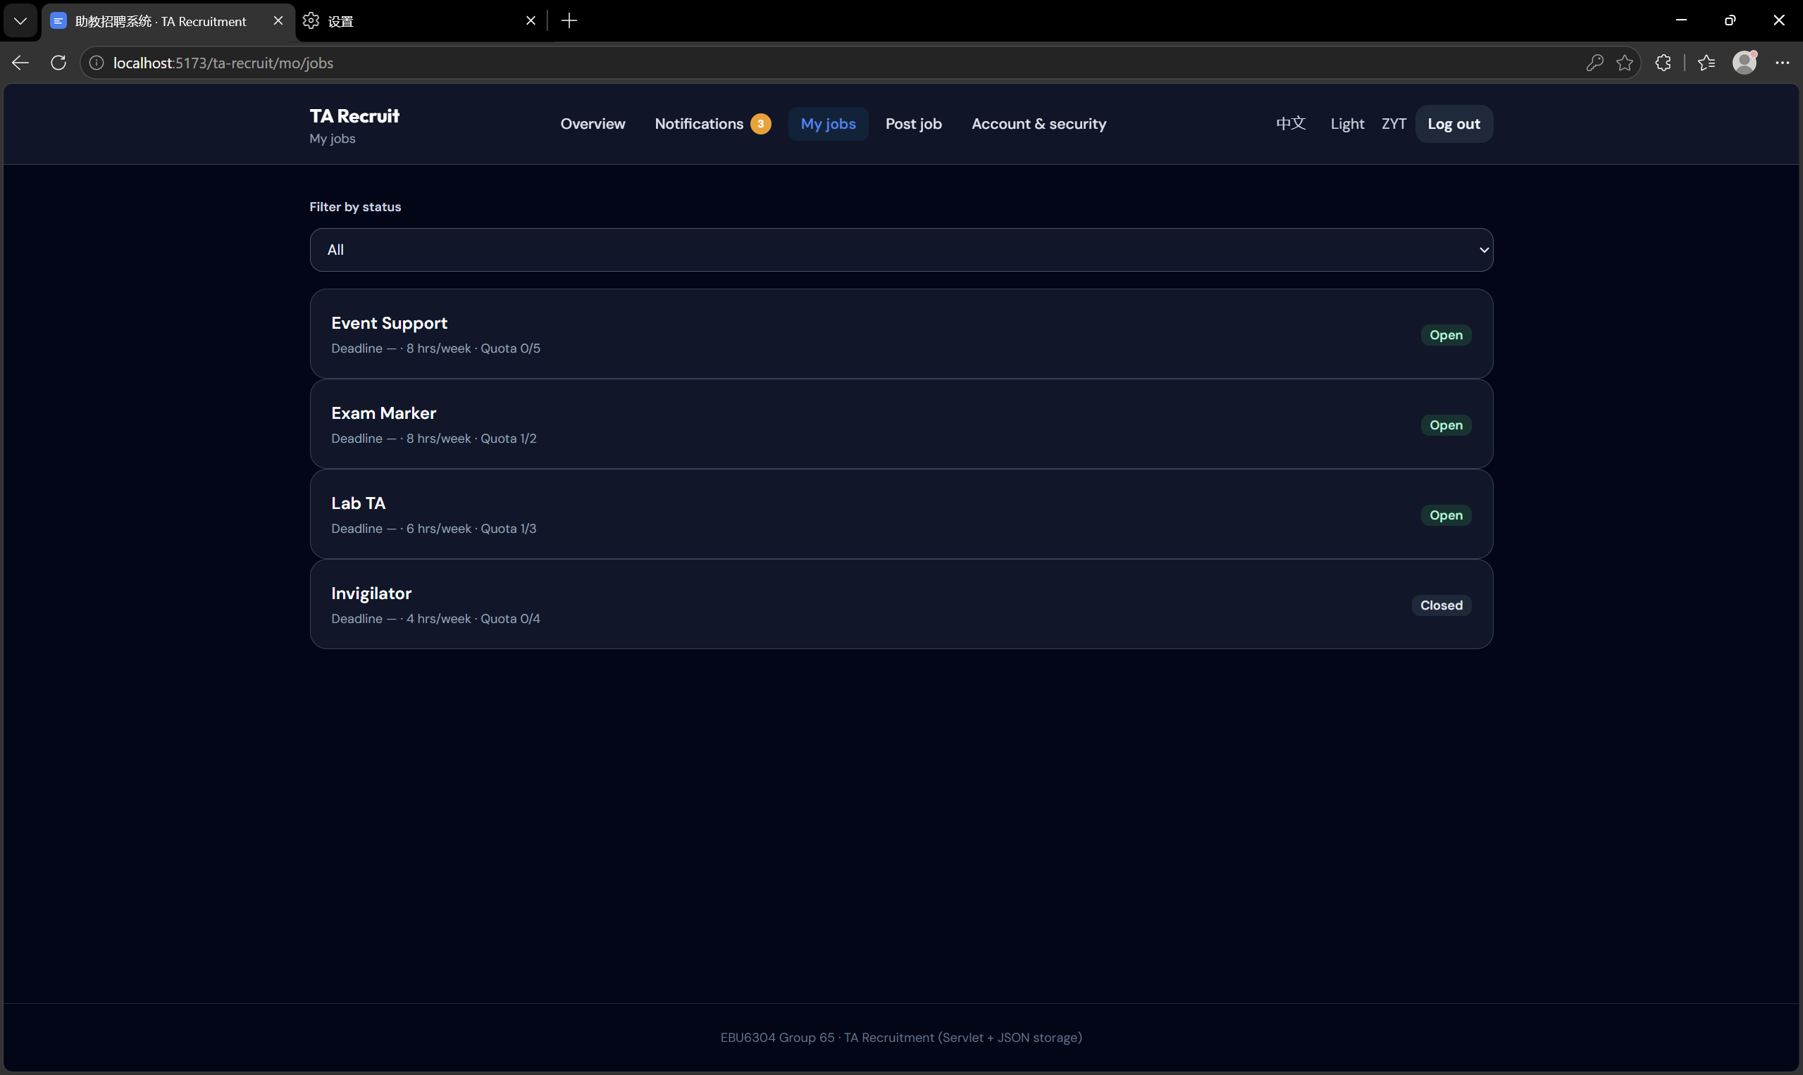

3. Click on a job to:
- View details
- Edit the job
- Close applications
- Delete the job

4.3 Review Applicants

1. Click on a job from My Jobs
2. Click Applicants tab
3. You will see all applicants for that job:
4. View applicant details and CVs

4.4 Evaluate Candidates

1. On the applicants page, click Evaluate for an applicant
2. Fill in the evaluation form:
- Skill match (1-10)
- Course experience (1-10)
- Academic background (1-10)
- Availability score (1-10)
- Communication (1-10)
- Notes

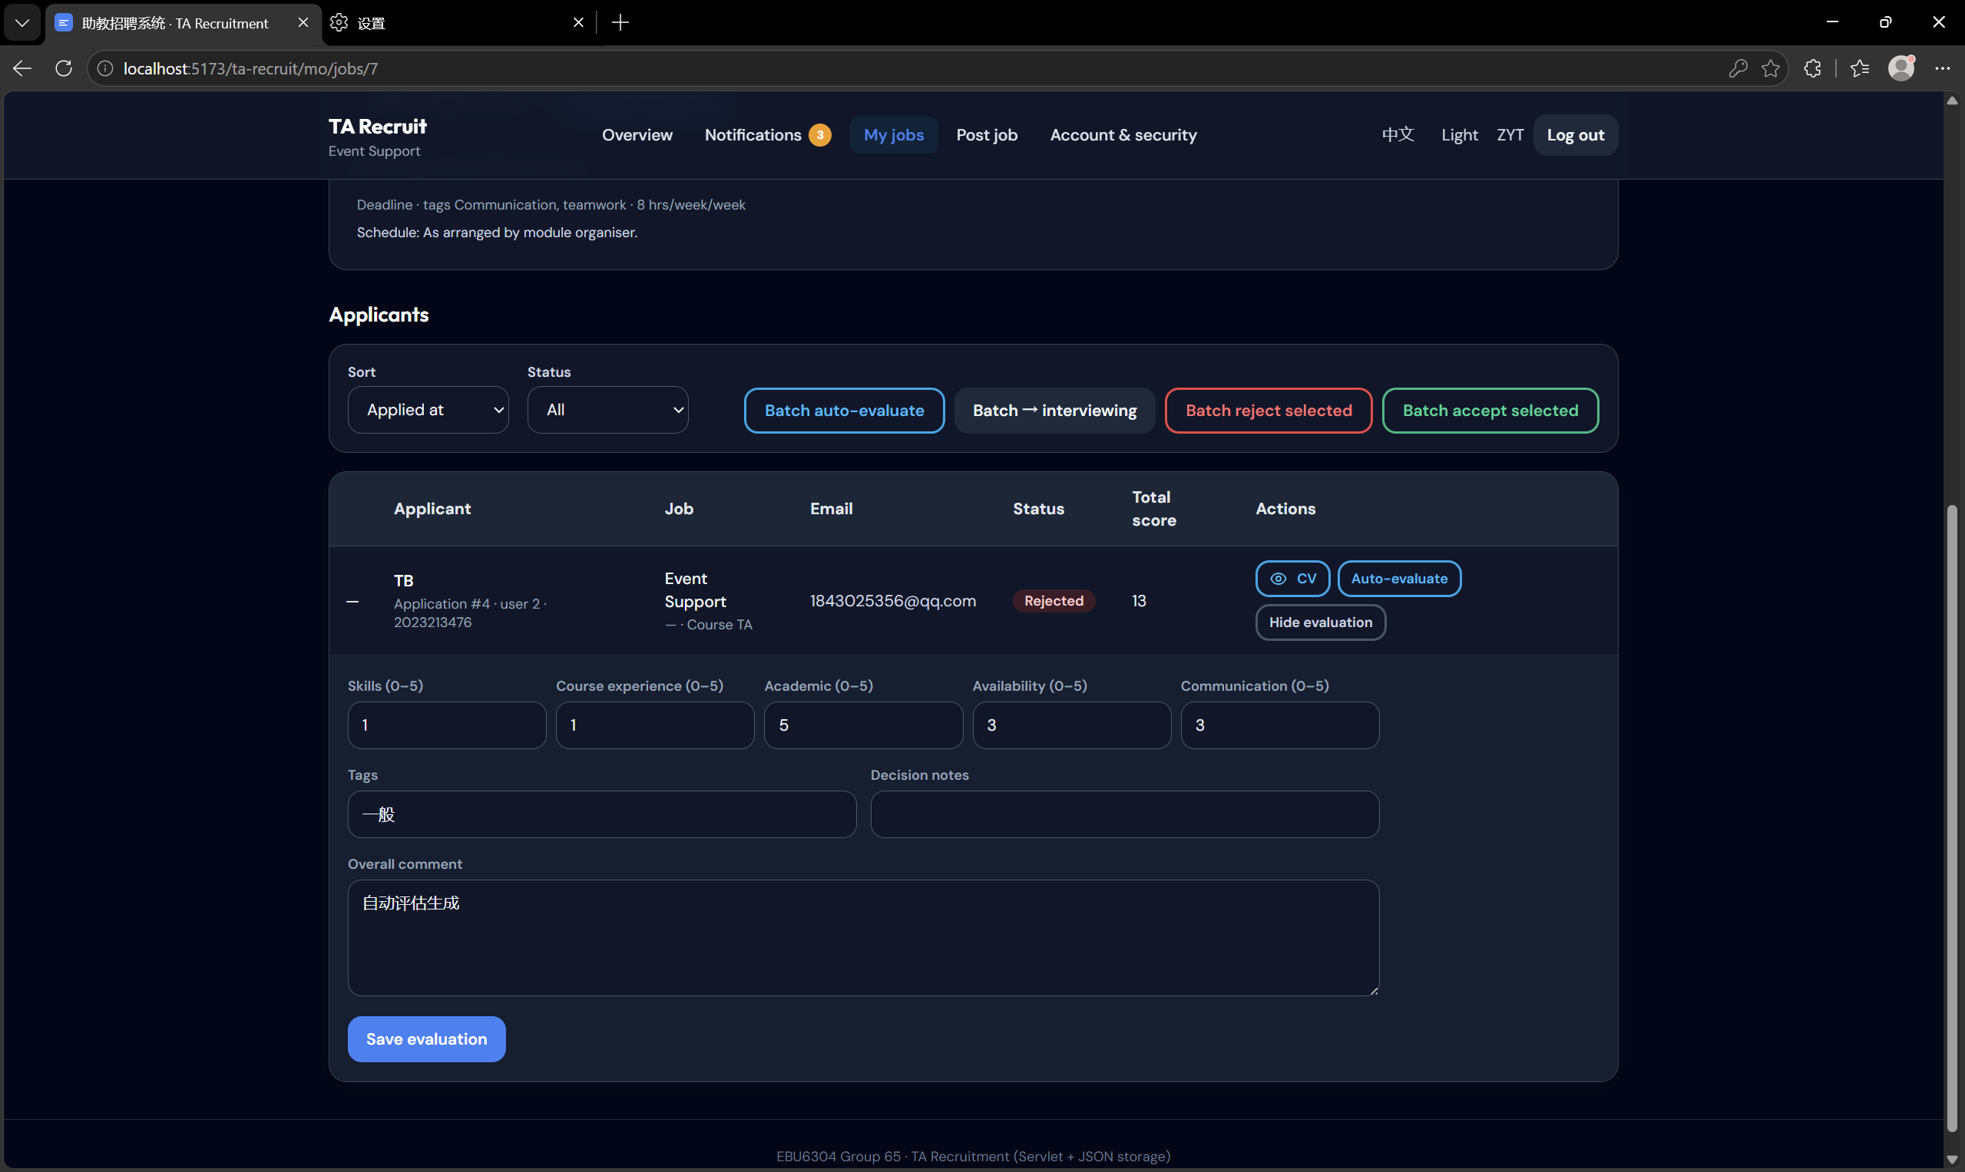
3. Click Save Evaluation

4.5 Make Decisions

1. Select applicants using checkboxes
2. Click Batch Decide button
3. Choose a status:
- Interviewing: Invite for interview
- Accepted: Offer the position
- Rejected: Decline the application
4. Click Confirm

5. Admin User Guide

As an Administrator, you can:
- Manage users
- Monitor workload
- View activity logs
- Configure system settings

5.1 Manage Users

1. Click Users in the navigation menu
2. You will see all system users:

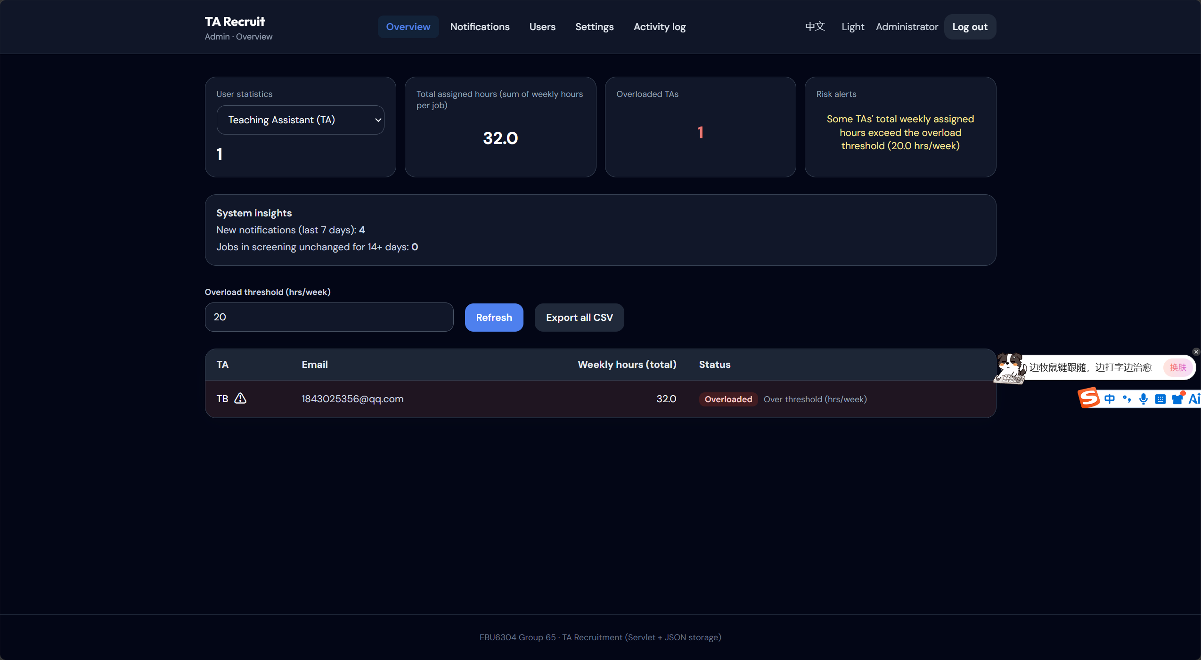
3. Search or filter users by role
4. Click on a user to:
- View details
- Edit user information
- Disable/enable account
- Delete user

5.2 Monitor Workload

1. Click Workload in the navigation menu
2. You will see TA workload summary:
3. View total hours per TA
4. Identify overloaded TAs (over 20 hours/week)
5. Export workload report as CSV

5.3 View Activity Logs

1. Click Logs in the navigation menu
2. See all system activities:
- User logins
- Job postings
- Applications
- Decisions

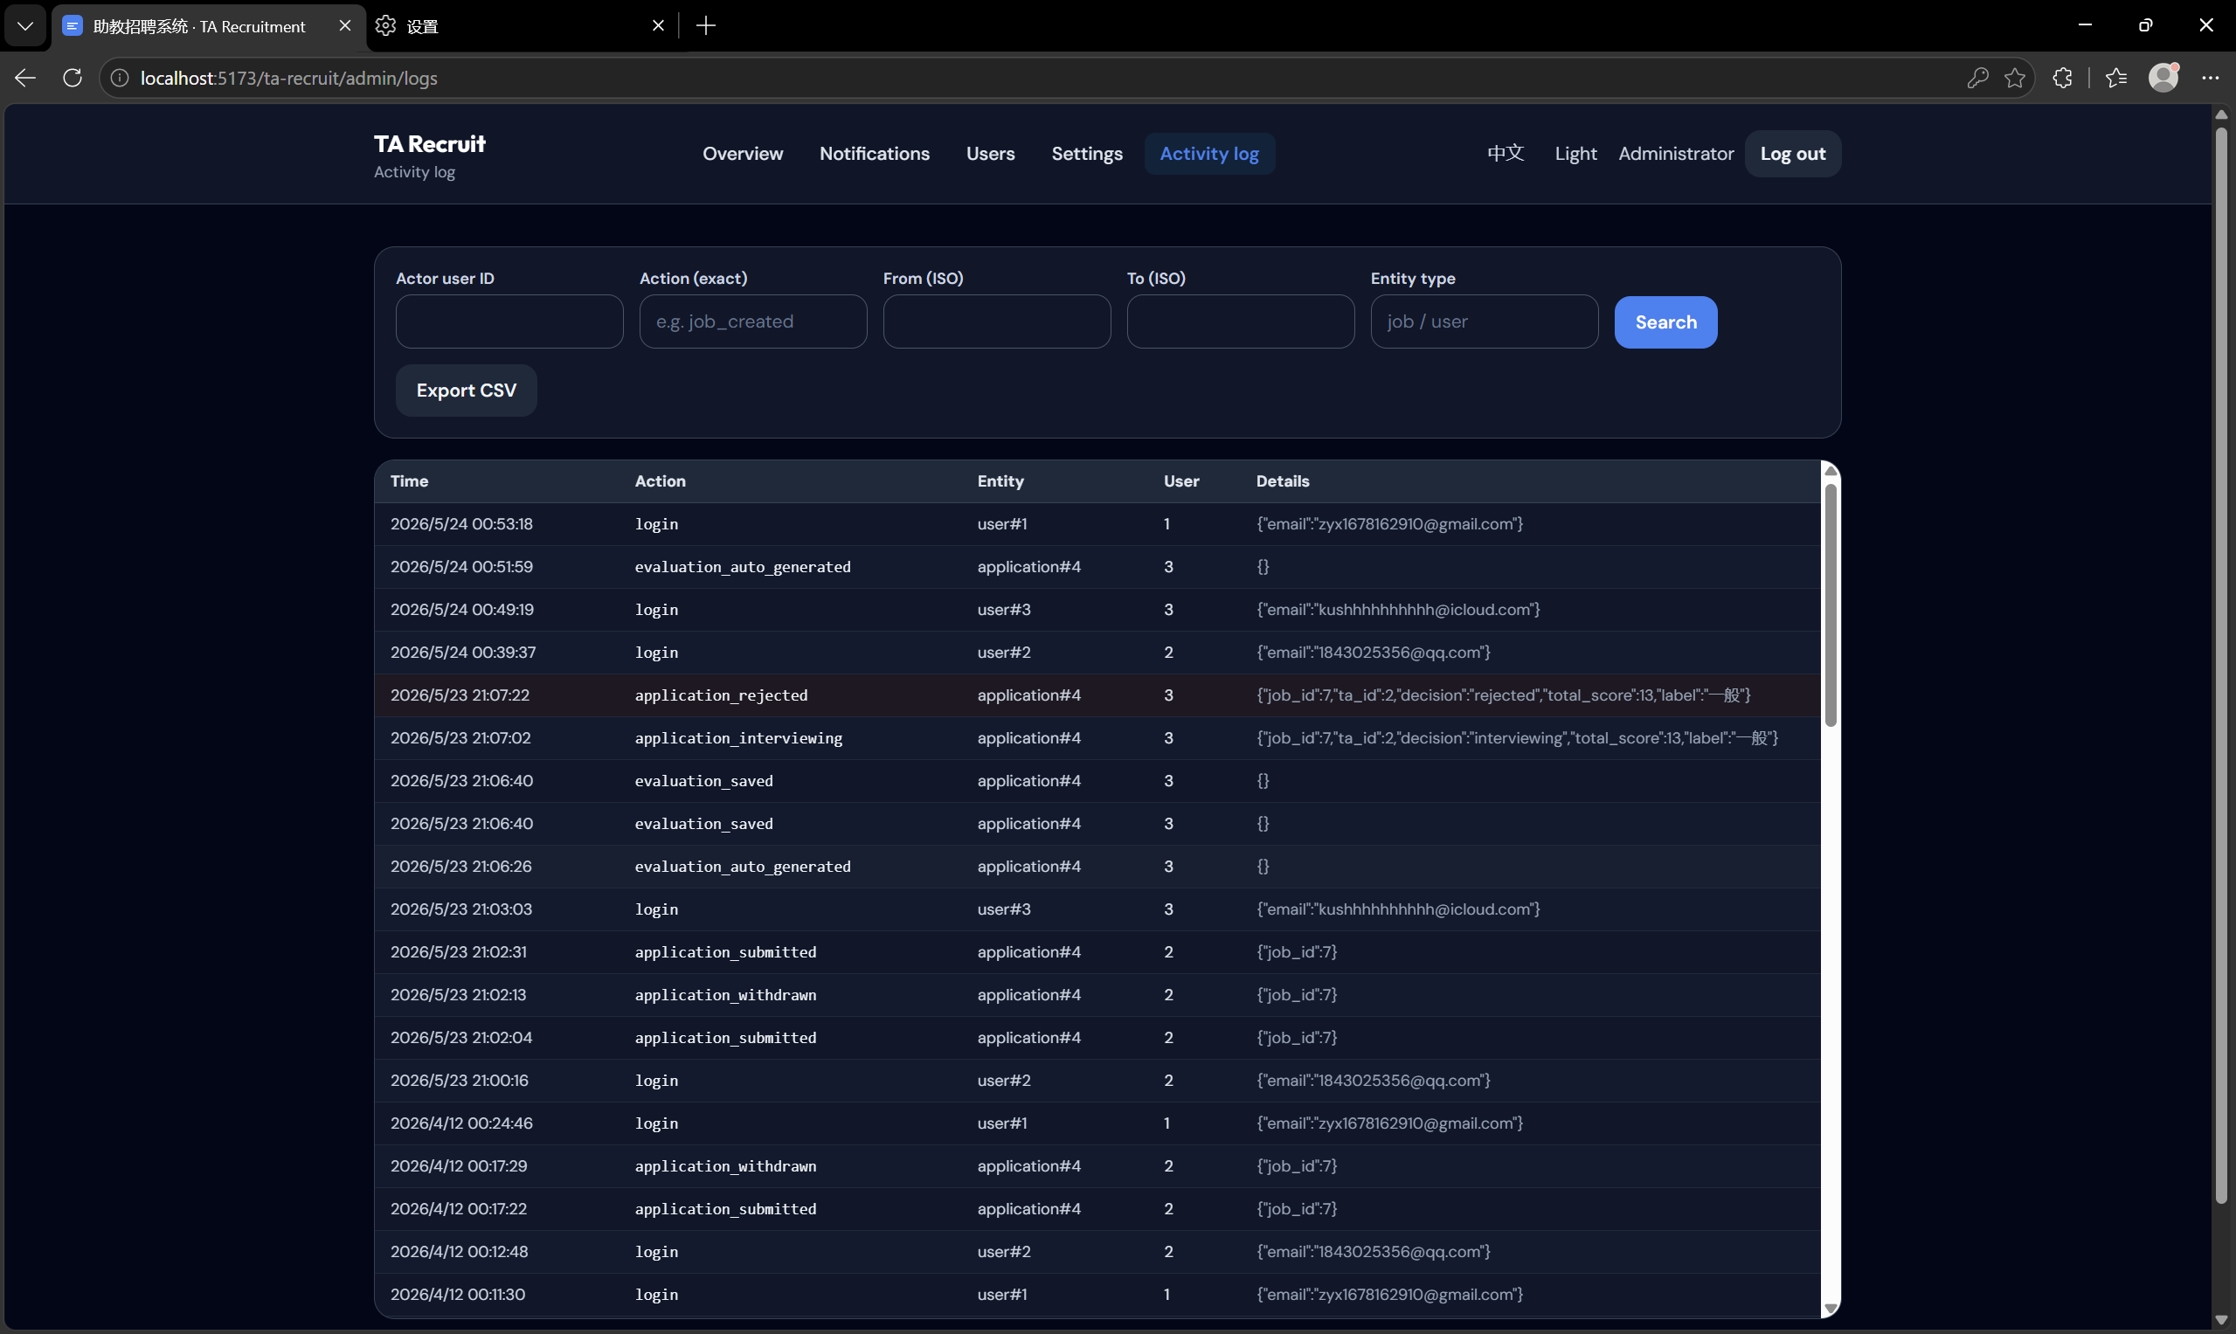
3. Filter logs by date, user, or action type

5.4 System Settings

1. Click Settings in the navigation menu
2. Configure system options:
- Maximum TA hours per week
- Notification settings
- Term dates
- Skill dictionary
- Overload threshold
3. Click Save Changes

6. FAQ

Q: How do I reset my password?
A: Click "Forgot Password" on the login page and follow the instructions.

Q: I can't find a job I applied for.
A: Check your My Applications page. Jobs may have been closed by the MO.

Q: How do I withdraw an application?
A: Go to My Applications, find the application, and click Withdraw.

Q: Why can't I see published jobs?
A: Make sure you are logged in with the correct role. Some jobs may be draft status.

Q: How do I export applicant data?
A: On the applicants page, click Export CSV button.

Last Updated: May 24, 2026

